Sun-Earth Relationship Quiz

- The condition of the atmosphere in one place during a short period of time is known as:
(For example a “cold, wet, windy day)
  - Weather
  - Rain Shadow
  - Ambient Temperature
  - Air Pressure
  - Climate

- The earth’s trip around the sun, 365 ¼ days, is known as:
  - Equinox
  - Deciduous
  - Rotation
  - Hypothesis
  - Revolution

- The revolution and of the earth cause changing seasons.
  - Tilt
  - Landmasses
  - Climate
  - Temperature

- Average weather patterns in a particular area are known as:
  - Greenhouse Effect
  - Climate
  - Doldrums
  - Ambient Temperature
  - Temperature

- Imaginary line running through the center of the earth is the:
  - Tilt
  - Climate
  - Axis
  - Rotation
  - Percipitation
- Equinox:
- Rotation:

  - Spin on the earth’s axis that takes 24 hours
  - Weather patterns an area experiences over a long time period
  - Trip around the sun that takes 365 ¼ days
  - Sun is directly over the equator so that day and night are equal in length
  - Imaginary line runs through the center of the earth

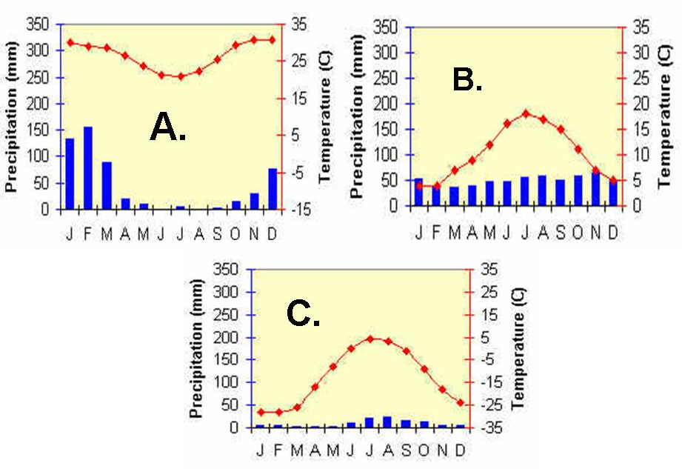

8) Which place is nearest to the North Pole?
9) Which place receives the least amount of precipitation?
10) Which graph is of a place in the southern hemisphere?
11) Which one is most likely to be found in the United Kingdom?
12) Which graph is of a place that is closest to the equator?
13) Which graph has the most consistent precipitation?
14) Which place has the least amount of precipitation deficit?
15) Where would be the best place to go to a beach vacation?

